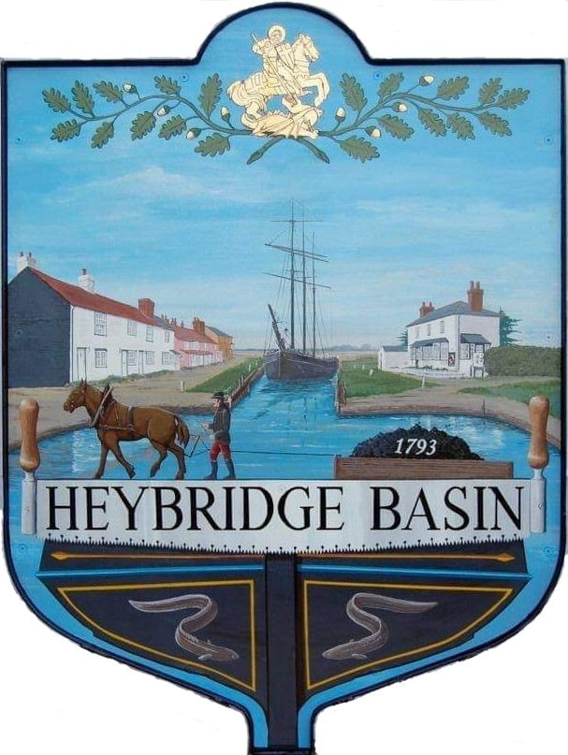

HEYBRIDGE BASIN PARISH COUNCIL

Minutes of the Extraordinary Council meeting of Heybridge Basin Parish Council held on Tuesday 17th September 2024 at 07:00pm, at St George’s Community Room.

PRESENT

In the Chair: M. Hodges (Chair) Absent: 0

Councillors: R. Bryson (Vice Chair) Apologies: 1
J. Sjollema
M. Hobden Public: 64
G. Howat
C. Edmond District Cllrs: 2

Officers: G. Lake – Clerk

It was noted that this meeting was being recorded by the Clerk.

24/089 Chair’s Welcome.
The Chair opened the meeting explaining the reason of the meeting and informed members of the public where the fire exits were and requested that mobile phones be silence.

24/090 To note apologies for absence.
Cllr Swann due to his Pecuniary Interest.

24/091 To receive Declarations of Interest in accordance with the Council’s Code of Conduct and with section 106 of the Local Government Finance Act 1992.
Cllr Hobden – Non-Pecuniary – HBSA, Basin Oars and HB River care; Cllr Edmond – Non-Pecuniary – Director of Cloughton Court Management and Essex Waterways; Cllr Howat – Non-Pecuniary – HB Conservation Society.

24/092 National Planning Policy Framework (NPPF)
  - To consider the draft response to the SLCC consultation regarding the proposed reforms to the NPPF and other changes to the planning system and agree any action to be taken.
It was resolved to not participate in the consultation.

24/093 The Former Timber Yard
24/00654/FULM – The Former Timber Yard – The demolition of the existing buildings and the construction of No.13 new dwellings and associated landscaping, access, car and cycle parking, and refuse and recycling provision.

- To receive a presentation from Govey Homes.
A presentation was received by Govey Homes Ltd outlining their proposed plans and the research they conducted to ensure the designs align as much as possible with the character of the village.

A short presentation was received showing the developers proposals for a commercial scheme for 20 Industrial Units.
- To receive a presentation from The Heybridge Basin Conservation Society.
A verbal report was received by the Heybridge Basin Conservation Society outlining pros and cons for the planning application.
- Public Participation
Resident feedback was mixed. The main concerns centred around traffic and access via Blackwater Close, as well as potential flood risks. However, many were in favour of the application, noting it as the best design they've seen for this site, especially given the current condition of the area, which many view as an eyesore.

A summary of the key points raised:

Traffic/Access: The roadway is currently designed as a loop, which raised security concerns among residents. They pointed out that roads with two exits/entrances are more vulnerable to break-ins. The developer responded that the loop was suggested by the Transport Strategy, but they are open to considering a one-way access system.

Opinions on the split access between Basin Road and Blackwater Close were also divided, with some in favour and others against.

Building Height: Concerns were raised about the height of the new houses compared to those in Blackwater/Burswood Close. The developers clarified that the tallest building is 3–4 meters from the southern side and isn’t significantly higher than those in Blackwater Close.

Land for Attenuation Tank: The developers have removed a house from their original plan to make room for an attenuation tank. They explained that this land cannot be used for additional development in the future due to the tank’s presence.

Energy Efficiency (NPPF Compliance): In line with the National Planning Policy Framework (NPPF) requirements for energy efficiency in new builds, the developer has proposed several sustainable features. These include the installation of PV panels for solar energy, thick insulation to improve warmth during the colder months, and provisions for EV charging.
- To consider the planning application and agree any action to be taken.
It was resolved that the Council would recommend the granting of planning permission subject to certain conditions: Contractual certainty to those promised benefits from the developer, reviewal of the use of Blackwater Close and re-routing traffic and that no future development is permitted on the land designated for the attenuation tank.

There being no further business the meeting closed at 08:27pm
Provisional Date of the next Council Meeting Tuesday 15th October 2024

Clerk Contact details: clerk@heybridgebasinpc.org.uk
Website: www.heybridgebasin-pc.gov.uk

